MACH4METAL

metalworking machinery
Transito 21, 6909 DA Babberich, Netherlands
Tel. + 31 (0)316 – 247123
Fax. + 31 (0)316 - 247956
info@mach4metal.com
www.mach4metal.com
Bank No : 66.52.13.883
IBAN : NL33 INGB 0665 2138 83
BIC : INGBNL2A
VAT : NL 815393635B01

VICTOR V-Turn 16 CNC lathe

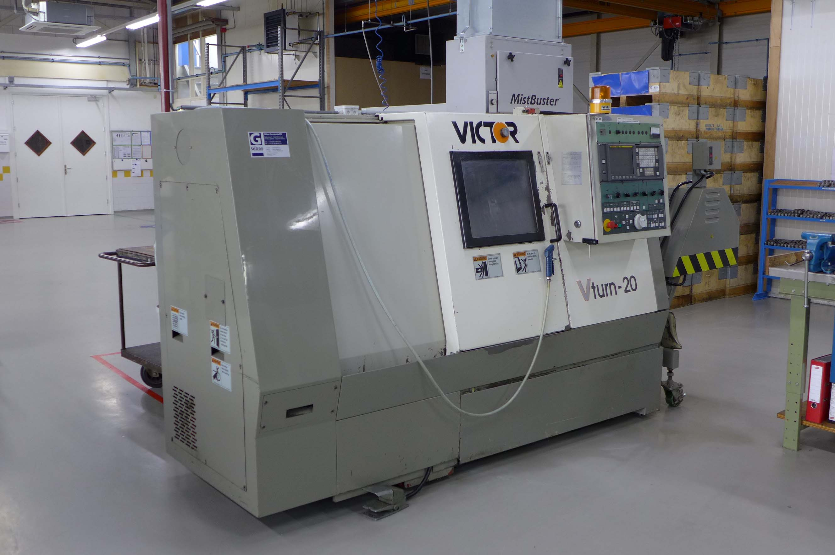
- Make : VICTOR Taiwan
- Typ : V – TURN 16
- Age : 1990
- Serial : MA 1147

- Swing over bed : 450 Ø
- Swing over carriage : 300
- DBC turning length : 635

- X Axis travel : 110 + 80
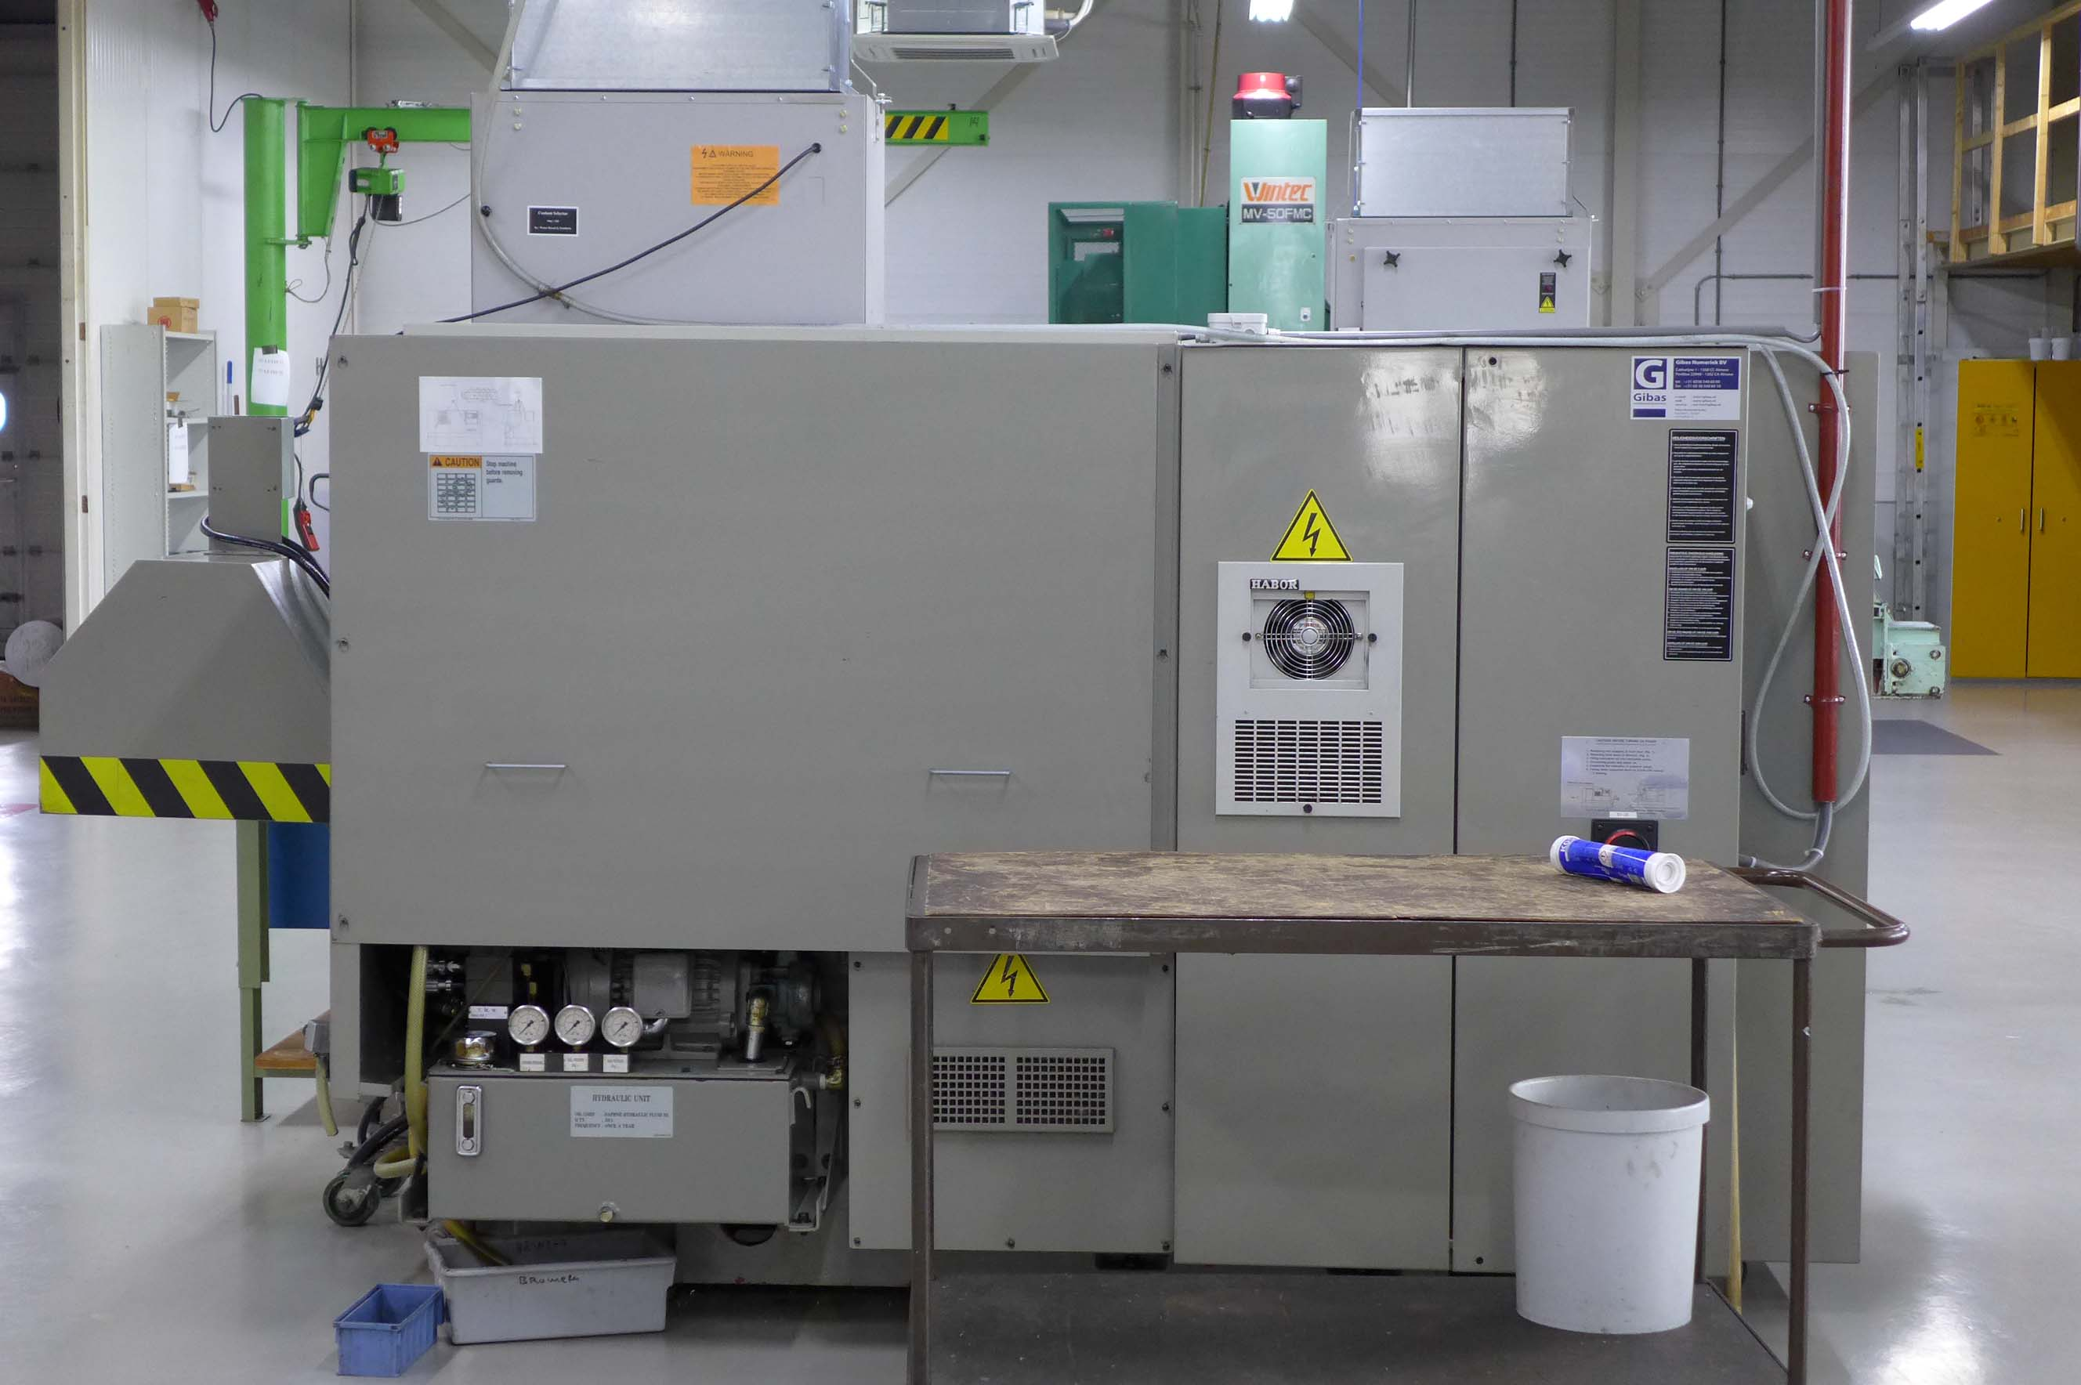
- Z Axis travel : 610
- Spindle bore : 52 / 62
- Spindle speeds Rpm : 6.000

- Turret revolver : 10 positions
- Tool shank / taper : Vdi 40

- Tailstock quill Ø : 75
- Stroke quill : 80
- Taper MK : 4
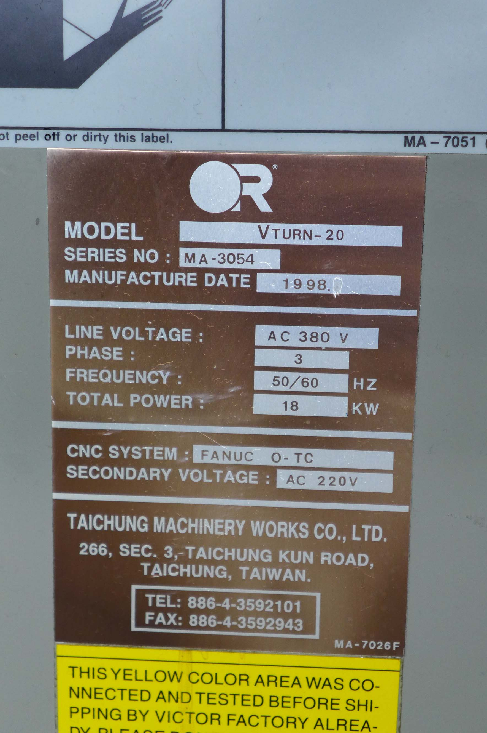

- Control FANUC O – TC
- Chip conveyor

- Large tooling package
- Large package with jaws
- From 1e owner !

- Dimensions
- Length : 3.300
- Width : 1.500
- Height : 1.650
- Weight : 4.000 Kg

Please Note: The above information has been obtained to the best of our ability and belief from, and from the manufacturers where possible. It is given in good faith, but its accuracy can not be guaranteed. Accordingly, it will not form a representation or constitute contractual terms. We advise you to check any vital details! !

